INTRODUCTION TO LINEAR MINING

Philip Venter
Magatar Mining, South Africa

ABSTRACT

Magatar Mining is a junior mining company that was formed recently. It has grown on the back of linear continuous mining (LCM) methodology that was patented and developed by Phangwa Mining. The methodology, as patented by Phangwa Mining affords the possibility to the continuous mining machine to be utilized on a totally different level than what was previously possible. A totally integrated logistic support system has been developed for the continuous miner; both in terms of continuous coal clearance and secondary logistic support in as far as all the other support systems inside and outside the production section is concerned:
- Incorporating onboard bolting for systematic roof support
- Section conveyor belt extension and retraction:
  - Installation and removal of belt structure
  - Installation and removal of conveyor belting
- Power supply support
- Water supply support
- Movement and replenishment of consumables; total palletization
- Spare parts and component movement
- Ventilation systems and support
- Maintenance requirements
- Stonedusting requirements
- Contractual agreements with suppliers; specific packaging to support the system

- INTRODUCTION

The linear mining principles were derived from the integration of various pieces of existing proven equipment available around the world.
The detailed system was developed into a workable, marketable system over the last four and a half years. The specific mining methodology, a form of linear mining had been patented by Phangwa Mining. Subsequent patents, which is a natural expansion of the original patent, has recently been filed and had been granted by the patent office. This patent has also been registered in various jurisdictions outside of South Africa.
Magatar Mining believes that the linear mining system offers a possible bridge between bord and pillar mining and longwall mining.

- EXISTING MINING METHODS IN A NUTSHELL

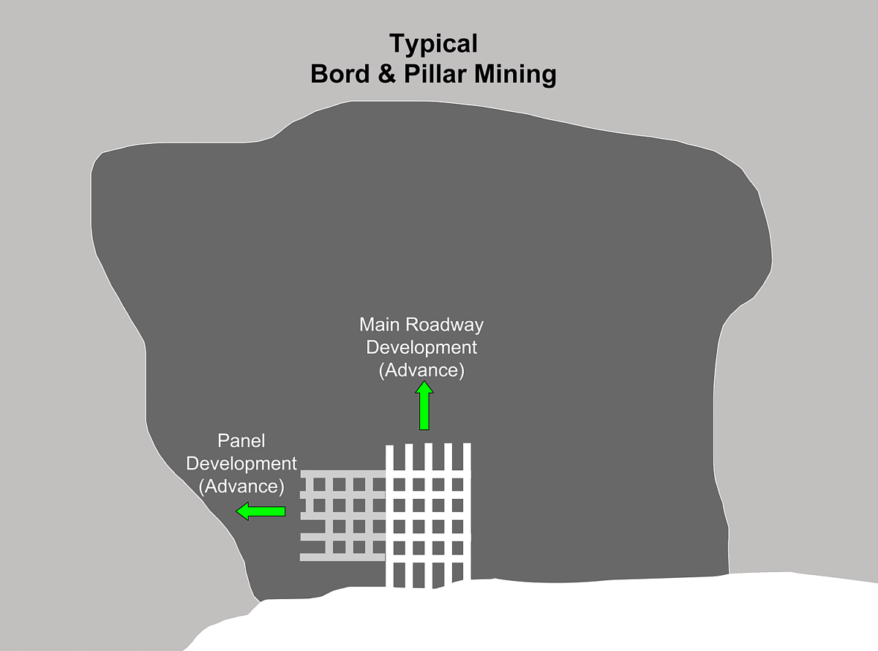
Bord and pillar mining is by far the most popular mining method in underground coal mines in South Africa. The reason for this choice is merely condition driven. In most of the South African coal reserves geological disturbances is fairly common, thus breaking up large portions of reserves into smaller pockets that cannot be mined economically by longwall methodology. The following figure shows the basic bord and pillar methodology as applied in most South African underground coal mines. The figure shows basic five road main development as well as secondary panel development.

Although the industry has seen significant improvements in output from bord and pillar sections there is still a large gap between bord and pillar and longwall mining.

Longwall mining is very popular for underground coal mining where conditions allow. One of the biggest challenges in terms of longwall mining is the timeous development of gate entry roads. The following figure shows a typical retreat longwall section, with gate entries developed from the main five road development entry.

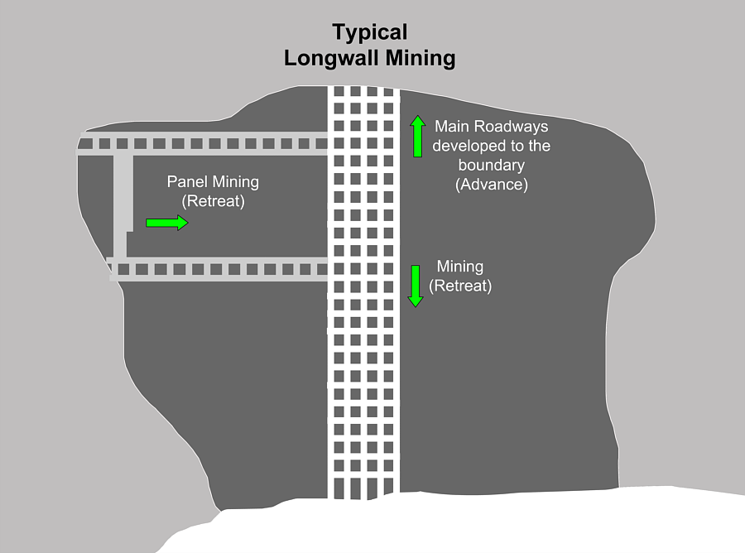

Production figures from a number of longwalls around the world have been impressive over a number of years, but most of these sections still suffer from inconsistent output. They have to be moved from time to time and if conditions are not well managed, a longwall on stop, buried or on fir,e can be an extremely costly exercise.

The pine feather system or modified Wongawilly system as used in some Chinese underground mines are shown in the following figure. Consistent high production figures have been achieved by sections using this methodology.

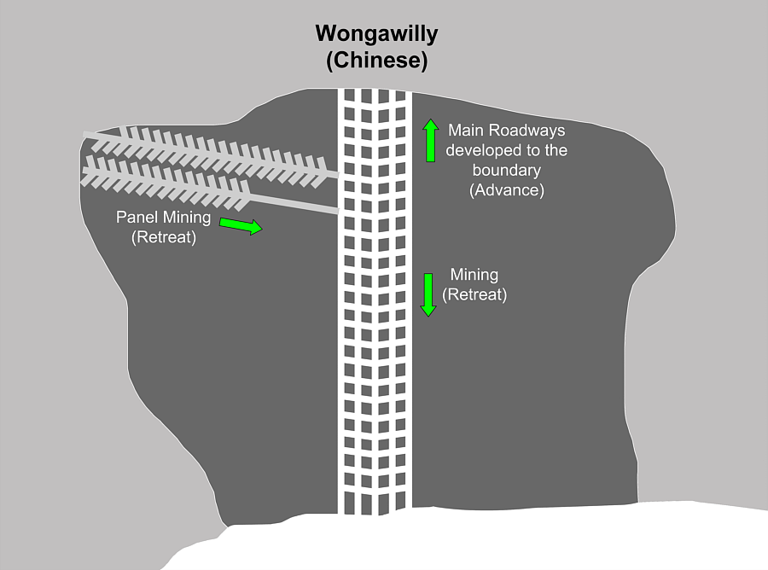

Production figures of well in access of 200 000 tons per month have been achieved by the use of this methodology (although there are some safety concerns).

- THE LINEAR MINING SYSTEM

Phangwa Mining initially identified the huge gap between continuous miner operations and longwalls as a potential opportunity. Where longwalls are achieving consistent production figures of up to and in access of 500 000 tons per month, it is extraordinary for continuous miner sections to produce more than 100 000 tons per month consistently. The following figure shows the basic linear mining system as patented by Phangwa Mining. Longwall sections that are achieving the above production rates are running at system utilization figures of close to 70%, whereas typical high production continuous miner sections in bord and pillar, combined with batching hauling, hardly ever achieve utilization figures higher than 35%. The linear mining methodology shown in the following figure allows the continuous miner utilization to be increased to figures in excess of 60%, which means that production figures in excess of 200 000 tons per month could become a reality.

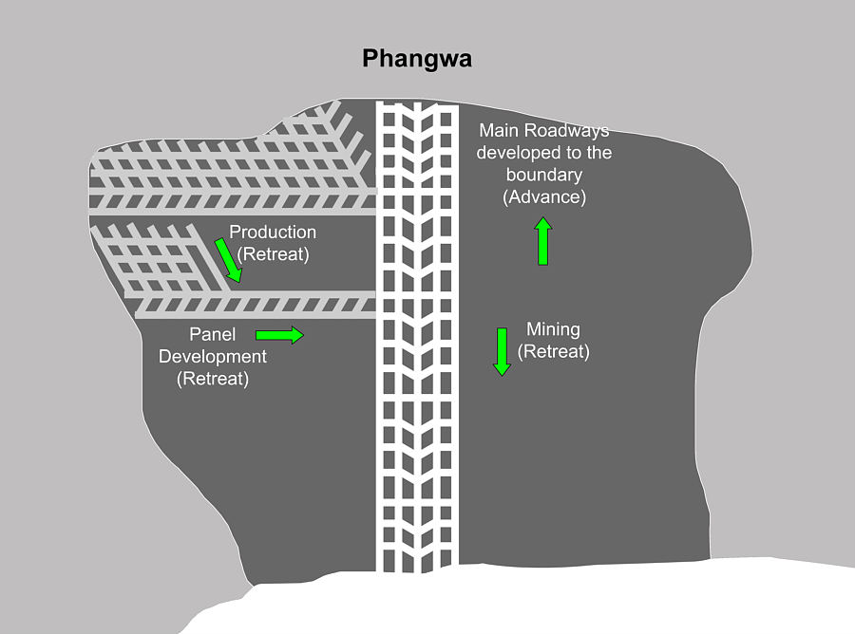

A linear mining section requires main development to be done for purposes of ventilation and access, as for all other mining methods. The linear mining system though, is capable of doing this development at close to normal production rates.
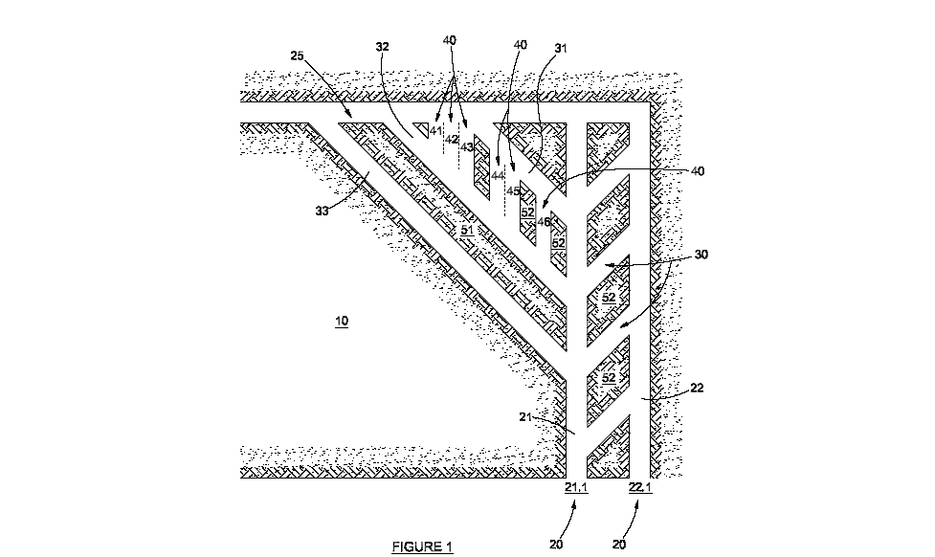
The sequence of events in a linear mining section can happen in many different ways, owing to the flexibility afforded by the system. One of the sequences is described in the following figure:

The numbering in the figure follows the following logic:
  - 10 is the virgin block of coal.
  - The 20 range is the primary entries into the virgin block of coal.
  - The 30 range is the secondary cuts/links between the entry roads and the linear cuts into the production block of coal.
  - The 40 range is the tertiary cuts into the pillars left between the secondary cuts; depending on conditions, these cuts could be higher or lower in number, but the specific sequence lends itself to more cuts owing to the retreat mode, thus always moving away from the dander zone.
  - The 50 range is essentially what stays behind after the cutting sequence has been completed and all possible material has been recovered.
The sequence shown here is just one of many sequences possible with the LCM methodology, due to the inherent flexibility of the system.

- ISSUES ADDRESSED BY THE LINEAR MINING SYSTEM

Strata Control (Rock Engineering) Issues
- The Phangwa system limits the number of entries into a virgin block of coal.
- The methodology lends itself perfectly for continuous systematic support, while at the same time affording a dramatic saving in roof support cost, due to the relatively safe (compared to other current systems) pillar extraction method employed.
- The safety factor on development roadways could be increased when compared to current multi-road development safety factors, resulting in a relatively safer working environment.
- Operators and other personnel are limited from entering higher risk areas, with lower, but still acceptable safety factors.
- The time spend in a production panel is decreased, due to higher production, resulting in a reduced risk associated with old workings.
- Limited entries into production panels make sealing off of worked out areas easier.
- Less people involved in the production process.
- All section personnel are machine bound, thus resulting in lower risk of roof falls or mobile machine accidents.
- The methodology is based on maximum advance rate with minimum roadways and maximum safety factor during the development phase. The production phase is characterised by a single narrow roadway, advanced without interruption and extraction of the pillar on the retreat (as explained earlier). The width of the pillar to be removed depends on the specific mining conditions.
Ventilation Issues
- The ventilation layout of the linear mining section is simple, with one road of the development used as intake and the belt road as return airway.
- Once the production cycle commences, the physical system is equipped with onboard ventilation ducting, which reduces the necessity of a secondary ventilation system, such as bratticing. The ventilation system will be different in lower seams where a similar amount of bratticing will be used.
- The linear mining system thus voids the necessity for the use of multiple ventilation fans in order to ventilate every heading. For most of the time headings are limited to one only; it is only during the primary entry development phase that two or three headings will be exposed. During the secondary and tertiary phases in the retreat process, only one heading has to be content with.
- During the development cycle, the dead ends that are created are ventilated with the introduction of a single auxiliary fan with a duct, which is moved after every cross-cut (link road between primary entry roads).
- The system can be adapted to ensure that the required volume of air is always available in the critical positions; where the machine is cutting.
- The ventilation system is set up in such a way as to allow for operators and other personnel to work in fresh air at all times.
- The system also lends itself to permanent interlocking of the ventilation system with the cutting machine; hard wired. The system will thus cut out under any condition of deficiency of ventilation.
Mining Issues
- Reduced inspection requirements at the beginning of each shift, owing to the reduction in the number of active entries and higher safety factors.
- Reduction in the number of people in the section as well as almost total elimination of people on foot in the section. Most section personnel are machine bound.
- Approximately 80% less physical manhandling tasks afforded by total mechanisation combined with palletizing of consumables and all other support requirements.
- Less machine manoeuvring due to the linear mining methodology combined with the specific supporting equipment.
- Highly repetitive system, less sequences, opportunity for optimal cutting; sumping, shearing, trimming, etc. utilization figures of up to 70% of the cutting machine becomes possible.
- Continuous process ensures minimum spillage and section messing; the geometry of the haulage system has been adapted to allow for maximum manoeuvrability and minimum spillage with in-chute scrapers fitted on every transfer point.
- The system is ideally suited for poor (soft) floor conditions:
  - The haulage system is very light; approximately 2 ton per wheel (chain haulage: 200-300tons, Flexiveyor: 80-100tons).
  - The haulage system moves in harmony with the cutting machine and conditions permit, will only tram over the same floor twice, once in when producing and once out into a new heading.
  - No dynamic floor loading as typically encountered with shuttle cars and battery haulers.
  - The system can handle continuous flows up to 850 tons per hour (about 40% higher than most continuous miners’ cutting rates), with slightly higher instantaneous loads.
- The cornering ability of the haulage system is good, due to the short car concept (individual cars are only 6m long) the system can go around 90 degree corners.
- It is believed that the resource utilisation could be increased with linear mining, due to the inherent safe mining practice that the system offers; constantly in retreat mode.
- The extraction ratio of coal could be increased to the optimum for specific conditions.
- The micro system/in-section system; that is the continuous miner, the haulage system, roofbolters and the mobile tailend is integrated, which ensures that the handling of cables in that area could is virtually eliminated.
- Product contamination could be reduced to a minimum due to the repetitive nature of the mining process; up to 100m in one go.
Engineering Issues
- The maintenance intensity requirements of the system is lower compared to other mining systems per ton produced, for the following reasons:
    - The system produces continuously.
    - The number of stop/starts of electric motors in the system is reduced to a minimum. (This could be as low as two starts per shift in high seam applications when compared to batching systems, which can be as high as 200 starts per shift).
    - The system optimizes the ratio between cutting and dead tramming.
- The reconditioning intervals on primary production machines, such as the continuous miner, should be increased significantly due to the specific mode of application, as described above.
Safety
- The safety advantages anticipated from the LCM methodology are considerable:
  - Almost total elimination of manhandling tasks.
  - Harmonious and slow movement of the total mining system; continuous miner, continuous haulage (Flexiveyor), section conveyor mobile tail end.
  - Hard interlocking of the ventilation system, ensuring elimination of any cutting when there is a deficiency of ventilation at the point of requirement.
  - The minimum number of personnel required per ton of production.
  - Systematic support by onboard bolting ensures proper strata control and a safe working environment from a roof perspective at all times.
  - The reduced manoeuvring of the cutting machine also reduces the exposure of operators to machinery accidents.
  - The utility vehicles combined with the recommended palletization of all consumables, spare parts, etc. also eliminates the carrying around of these items to a large extend.
  - All maintenance related tasks are also supported by the utility vehicle concept, where tools, lubricants, etc are mechanically brought to the point where it is required.
  - The total system is well lit, which should be conducive to a safe working environment.
  - Extensive live testing of the system has indicated minimal spillage, which should further enhance the working environment in the production section.
- The main messages in respect of safety with regard to the LCM methodology are:
  - That the system lends itself to very good practices with regard to general safety.
  - The physical workload of personnel in the production section is significantly reduced.
  - The machinery supporting the continuous miner is generally light, but with high throughput capacity, making maintenance easy.
  - The haulage system is also void from abrupt movements; it literally moves harmoniously forward and backward in its own tracks, with no or minimal sideways movement of the system.
  - Since mostly common or simple new equipment is utilized, it is believed that the system offers a generally safe environment.

Environmental issues
- The logistic support system has been adopted to address current burning issues, such as;
  - The proper handling of used oil.
  - The proper handling of used material; such as picks, oil filters, cloth wire, pipes, etc.
  - The smooth supply and removal of new and used items to and from the production section.
  - Excessive stockholding of material and parts on the mine.
  - Excessive storage facilities.
  - Long term agreements with suppliers to ensure security of supply and proper planning practice.
  - The total issue of packaging of consumables and parts, ready fro use by the production section.
  - Generally making things physically easier on personnel, supporting the high production outputs expected of them.
- The LCM methodology also lends itself to mining practice that has the ability to gain higher resource utilization, which boils down to higher extraction ratios.
- It is also possible to adapt the system to allow for maximum extraction of a reserve, without collapse of the overburden, since the major process occurs in the retreat mode. The inherent flexibility of the system allows for new techniques to be implemented, whereby the size of pillars could be optimized to allow for “sagging” of the overburden instead of “breaking”, which could theoretically conserve the water table, thus reducing the environmental impact of coal extraction.
- The kilowatt per tonne of coal produced is also slightly lower with the LCM methodology and supporting system as proposed, but the major advantage lies in the installed power required for a whole mine. The system can produce up to double the tonnages from a single section than what is currently the case in seams above 2.5m, in the best production sections and even more in lower seams such as 5 seam (system can mine as low as 1.5m seams). The environmental connection here is thus that if a whole mine with multiple sections is considered, that up to 30% less maximum demand power would be required for similar tonnages when compared with traditional methodology.

- CAPABILITIES OF THE LINEAR MINING SYSTEM

The linear mining system, as developed by Phangwa Mining, addresses most of the historical issues that prevents high utilization of typical continuous mining systems, without changing the basic machinery (equipment).
The capabilities of the linear mining system are summarized in the following graph:

CM Cutting Rate Comparison
tonne per month
0
50000
100000
150000
200000
250000
300000
1.5
2.5
3.5
4.5
5.5
Seam height (m)
Phangwa max
Phangwa min
B&P max
B&P min
CM capacity
SA1 Herring
SA2 Own
SA3 B&P
China Herring

First off, the cutting capability (full cycle) of the continuous miner is shown as the red line (triangles at approximately 280 000 tons per month, all based on the same shift system, exept the reference to the Chinese mine, which are working a fulco system). This shows what should be possible from an ideal section where the coal is cleared from behind the continuous miner on a continuous basis with no hold-ups, break-downs or repositioning. This should be the ideal to strive for.

The two green lines (B&P max and B&P min) show the production tonnage band possible using the Bord and Pillar method. The poor performance in relation to the ideal is mostly owing unnecesary tramming, maneuevering and repositioning of the CM and the coal being cleared from behind the CM in batches (shuttle cars or battery haulers). A large portion of the CM activity is thus to maneuever and wait for haulers. Bord and Pillar is a rather complex method with lots of opportunities for things to go wrong.

The two blue lines (Phangwa max and Phangwa min) show the production band possible from the Phangwa method. Although still far from the ideal, it is a vast improvement on the Bord and Pillar method. Most of the defficiencies of the typical Bord and Pillar method has been adressed, i.e. a continuous haulage system is used for continuous coal clearance and the cutting sequence has been simplified to eliminate unnecesary tramming and maneuevering. The question is whether this is new or unique and thus associated with any risk. Also important to note is that with the LCM methodology it is possible in seams as thin as 1.5m to compete favourably in terms of output and thus cost to seams in excess of 3m with Bors and Pillar.

The SA1 herring on the graph indicates the tonnages achieved by a SA mine using chain haulage systems. There are only two coal mines in SA using continuous haulage systems; SA1 mine in a 4m seam applying a herringbone type layout. This site can be considered to be somewhere between the B&P and the LCM methodology in terms of optimization. It is clear from the graph that SA1 is achieving production rates between B&P and the LCM methodology. SA1 has ahcieved these figures consistently over a number of years. The second mine is SA2 also using continuous haulage systems, but in a much lower seam (down to 1.5m). The SA2 method is a modified B&P layout to minimize tramming and makes use of some of the capabilities promised by a continuous haulage system. Again, SA2 is achieving tonnages somewhere between B&P and what is considered to be achievable by the LCM methodology.

The last example is a Chinese mine that is achieving tonnages in excess of the Phangwa predictions, using continuous haulages and a Pinefeather cutting layout. The reason for the Chinese achieving higher tonnage than Phangwa is purely owing to the Chinese working 24 hours per day and 7 days a week. The Phangwa tonnages are based on a 5 day week and a 20 hour day (2 x 10 hour shifts). If the same working schedule is applied to Phangwa, Phangwa will produce similar tonnages to the Chinese.

It might be asked why Phangwa does not simply copy the Chinese method and eliminate all supposed risks. Phangwa has spent 4 years in analysing and optimizing cutting methods to achieve the simplest, safest and most repetitive and sustainable method. Equipment have also been carefully chosen to minimize manhandling and thus minimizing manpower requirements, without compromising safety. Compliance with SA safety regulations and other general safety requirements have also been a priority and the Phangwa method is far safer than the Chinese method, or B&P for that matter.

- ECONOMICS OF THE LINEAR MINING SYSTEM

The LCM methodology is made possible with the integration of mostly known technology, packaged and logistically integrated to make high utilization and subsequent high tonnage output from continuous miners a possibility.

The capital outlay of a LCM section is very similar to a traditional bord and pillar continuous miner section using batching technology (shuttle cars or battery haulers). Owing to the specific methodology developed by Phangwa, a number of cost drivers in the section are positively addressed with the following results that realise from the use of the LCM methodology:
  - Up to 60% reduction in the manoeuvring of the continuous miner.
  - Up to 25% reduction in “dead” tramming of the continuous miner.
  - More than 75% improvement in the output from a single production section, assuming similar conditions. The following tables give a further indication of possibilities.

Low Seams (below 2m)

B&P  Drill and Blast  Single | B&P  CM/batching | Herringbone  CM/Cont Haulage | Phangwa  CM/Flexiveyor
15 000 t/mth  Proven | 35 000 t/mth  Proven/Simulated | 75 000 t/mth  Proven | 120 000 t/mth  Simulated

High Seams (above 2m)

B&P  CM/batching | B&P/Herringbone  CM/Cont Haulage | Pine Feather  CM/cont haulage | Phangwa  CM/Flexiveyor
100 000 t/mth  Proven | 130 000 t/mth  Proven/Simulated | 200 000 t/mth  Proven | 200 000 t/mth  Simulated

  - Up to 50% fewer personnel for similar production output.

- INTEGRATED LOGISTICS

The LCM methodology and supporting systems can be considered to be a totally integrated logistic system. Not only has the coal cutting and conveying system been integrated and afforded the possibility to cut for extended distances in one direction, but also the support systems behind it:
  - The ventilation system has been integrated onto the coal clearance system.
  - The section conveyor support structure can be deployed and removed on the fly (if required).
  - All the consumables, spares, etc has been integrated back to the suppliers.
  - A logistic system has been derived to ensure an uninterrupted stream of supplies into the production section.
  - Utility vehicles fitted with quick detachable systems ensure that numerous tasks in the section can be performed without physical effort from personnel:
- Installing and replenishing conveyor belting.
- Installing and removing conveyor belt structure.
- Installing and removing auxiliary ventilation systems.
- Replenishing consumables in the section.
- Exchanging new and used pallets in the section carrying consumables, etc.
- Carrying spare parts and components.
- Carrying lubricants and tools for maintenance purposes.
- Could be used to clean the section.
- These vehicles are also fitted with hydraulic power take off systems to ease maintenance tasks for technical personnel.

- GENERAL
The LCM methodology has been dissected into all possible categories:
- What-if analysis
- Risk analysis and profiles
- Different mining conditions
- Etc.
But for purposes of this paper the content is deemed to be sufficient to awaken the thoughts and thought processes of prospective change agents in the industry.

- CONTACT DETAILS
Philip Venter: pventer@magatar.com
Tel: +27845566590
Hein Lass: hlass@magatar.com
Tel: +27823756424
Muzorewa Ratshikuni: mratshikuni@magatar.com
Tel: +27765442300

